Thục hành tuần 2:
Nguyễn đức phát - 1150080152 - Lớp: THMT

Lab3:
Bài1:
- Tạo Bai1Activity.java
<?xml version="1.0" encoding="utf-8"?>
<LinearLayout xmlns:android="http://schemas.android.com/apk/res/android"
android:orientation="vertical"
android:gravity="center"
android:padding="24dp"
android:layout_width="match_parent"
android:layout_height="match_parent">

<TextView
android:id="@+id/tv_title"
android:text="@string/bai1_title"
android:textSize="20sp"
android:layout_marginBottom="24dp"
android:layout_width="wrap_content"
android:layout_height="wrap_content" />

<Switch
android:id="@+id/switch_orientation"
android:text="@string/switch_label"
android:textSize="18sp"
android:layout_width="wrap_content"
android:layout_height="wrap_content" />
</LinearLayout>

- M000SplashFrg.java
package com.example.truyencuoi;

import android.os.Bundle;
import android.os.Handler;
import android.view.LayoutInflater;
import android.view.View;
import android.view.ViewGroup;
import androidx.fragment.app.Fragment;

public class M000SplashFrg extends Fragment {

@Override
public View onCreateView(LayoutInflater inflater, ViewGroup container,
Bundle savedInstanceState) {
View view = inflater.inflate(R.layout.m000_frg_splash, container, false);
new Handler().postDelayed(this::gotoM001Screen, 2000);
return view;
}

private void gotoM001Screen() {
if (getActivity() != null) {
((MainActivity) getActivity()).gotoM001Screen();
}
}
}

- MainActivity.java
package com.example.truyencuoi;

import android.content.Intent;
import android.os.Bundle;
import androidx.appcompat.app.AppCompatActivity;
import androidx.fragment.app.Fragment;

public class MainActivity extends AppCompatActivity {

@Override
protected void onCreate(Bundle savedInstanceState) {
super.onCreate(savedInstanceState);
setContentView(R.layout.activity_main);
showFrg(new M000SplashFrg());
}

private void showFrg(Fragment frg) {
getSupportFragmentManager().beginTransaction()
.replace(R.id.ln_main, frg, null)
.commit();
}

// 👉 Hàm được gọi sau khi splash xong
public void gotoM001Screen() {
startActivity(new Intent(this, Bai1Activity.class));
finish(); // không quay lại splash
}
}

- layout/activity_bai1.xml
<?xml version="1.0" encoding="utf-8"?>
<LinearLayout xmlns:android="http://schemas.android.com/apk/res/android"
android:orientation="vertical"
android:gravity="center"
android:padding="24dp"
android:layout_width="match_parent"
android:layout_height="match_parent">
<TextView
android:id="@+id/tv_title"
android:text="@string/bai1_title"
android:textSize="20sp"
android:layout_marginBottom="24dp"
android:layout_width="wrap_content"
android:layout_height="wrap_content" />
<Switch
android:id="@+id/switch_orientation"
android:text="@string/switch_label"
android:textSize="18sp"
android:layout_width="wrap_content"
android:layout_height="wrap_content" />
</LinearLayout>

- layout/m000_frg_splash.xml
<?xml version="1.0" encoding="utf-8"?>
<FrameLayout xmlns:android="http://schemas.android.com/apk/res/android"
android:layout_width="match_parent"
android:layout_height="match_parent"
android:background="@color/greenMid">

<ImageView
android:layout_width="200dp"
android:layout_height="200dp"
android:layout_gravity="center"
android:src="@drawable/ic_splash"
android:contentDescription="@string/app_name" />
</FrameLayout>

- layout/activity_main.xml
<?xml version="1.0" encoding="utf-8"?>
<LinearLayout xmlns:android="http://schemas.android.com/apk/res/android"
xmlns:tools="http://schemas.android.com/tools"
android:id="@+id/ln_main"
android:layout_width="match_parent"
android:layout_height="match_parent"
android:orientation="horizontal"
tools:context=".MainActivity" />

- drawable/ic_splash.xml
<vector xmlns:android="http://schemas.android.com/apk/res/android"
android:width="200dp"
android:height="200dp"
android:viewportWidth="24"
android:viewportHeight="24">
<path
android:fillColor="#478942"
android:pathData="M12,2C6.48,2 2,6.48 2,12s4.48,10 10,10 10,-4.48 10,-10S17.52,2 12,2zM11,17h2v-2h-2v2zM11,7h2v6h-2V7z"/>
</vector>

- values/strings.xml
<resources>
<string name="app_name">Truyện Cười</string>
<string name="bai1_title">Bài tập 1: Xoay ngang hoặc không</string>
<string name="switch_label">Cho phép xoay ngang (On/Off)</string>
</resources>

- values/colors.xml
<resources>
<color name="purple_200">#FFBB86FC</color>
<color name="purple_500">#FF6200EE</color>
<color name="purple_700">#FF3700B3</color>
<color name="teal_200">#FF03DAC5</color>
<color name="teal_700">#FF018786</color>
<color name="black">#FF000000</color>
<color name="white">#FFFFFFFF</color>
<color name="greenMid">#478942</color>
</resources>

- values/themes.xml
<?xml version="1.0" encoding="utf-8"?>
<resources xmlns:tools="http://schemas.android.com/tools">
<style name="Theme.TruyenCuoi" parent="Theme.MaterialComponents.DayNight.NoActionBar">
<item name="colorPrimary">@color/purple_500</item>
<item name="colorPrimaryVariant">@color/purple_700</item>
<item name="colorOnPrimary">@color/white</item>
<item name="colorSecondary">@color/teal_200</item>
<item name="colorSecondaryVariant">@color/teal_700</item>
<item name="colorOnSecondary">@color/black</item>
<item name="android:statusBarColor" tools:targetApi="l">?attr/colorPrimaryVariant</item>
</style>
</resources>

- AndroidManifest.xml
<?xml version="1.0" encoding="utf-8"?>
<manifest xmlns:android="http://schemas.android.com/apk/res/android"
package="com.example.truyencuoi">

<application
android:allowBackup="true"
android:icon="@mipmap/ic_launcher"
android:label="@string/app_name"
android:roundIcon="@mipmap/ic_launcher_round"
android:supportsRtl="true"
android:theme="@style/Theme.TruyenCuoi">

<activity android:name=".Bai1Activity" />

<activity android:name=".MainActivity"
android:exported="true">
<intent-filter>
<action android:name="android.intent.action.MAIN" />
<category android:name="android.intent.category.LAUNCHER" />
</intent-filter>
</activity>

</application>
</manifest>
Kết quả:
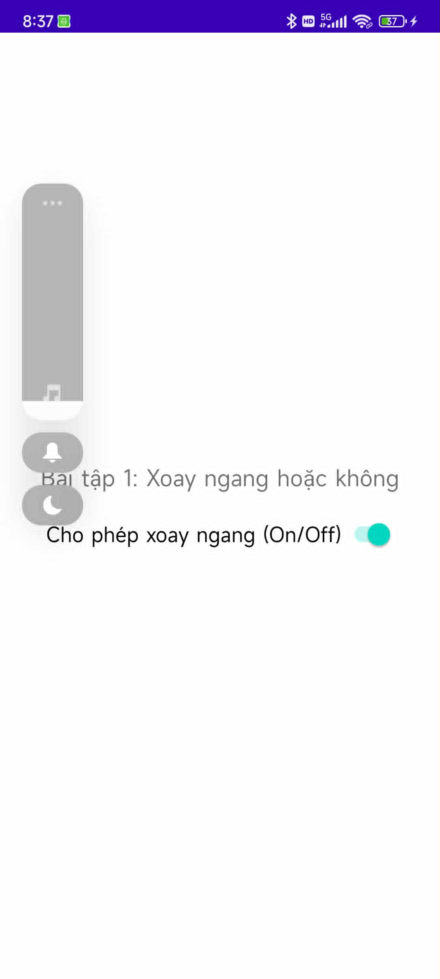
-----------------------------
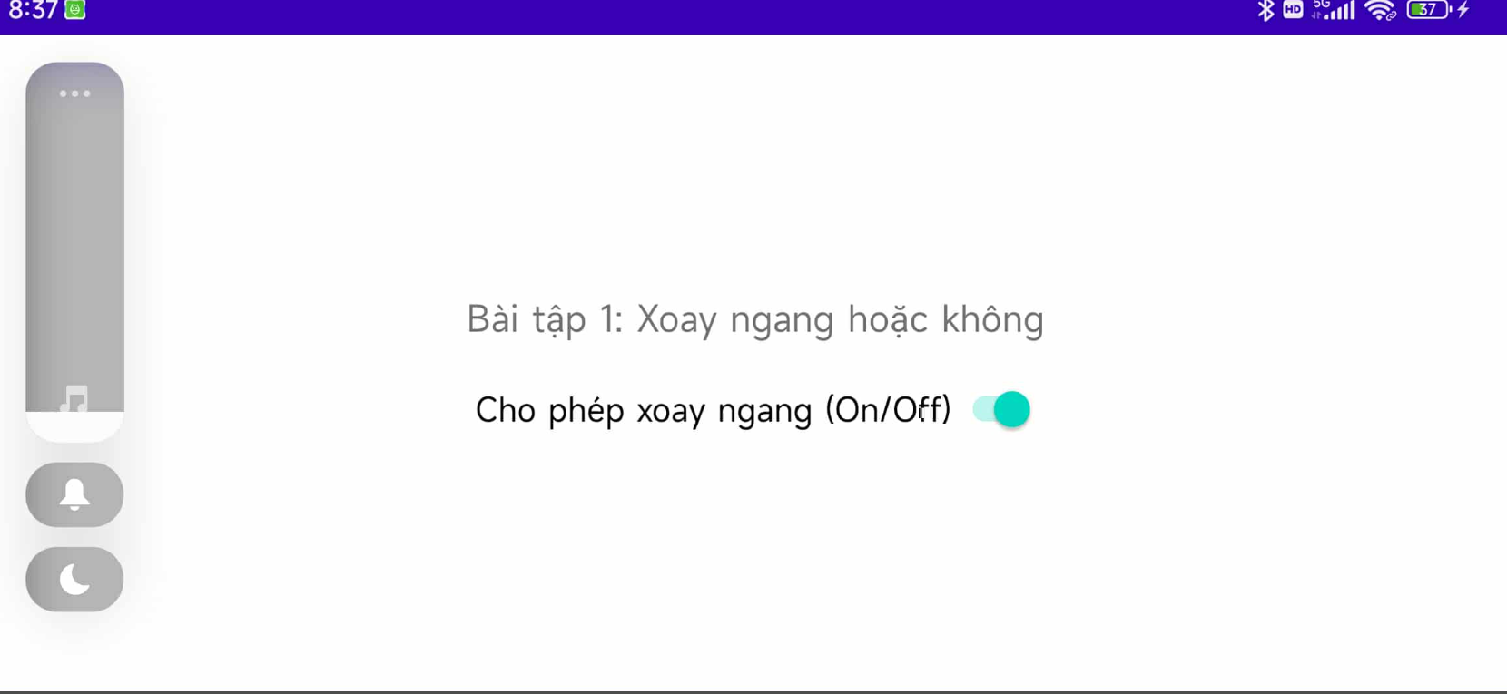

Bài 2:
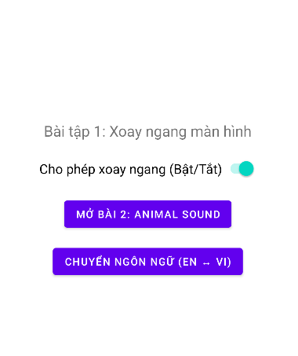
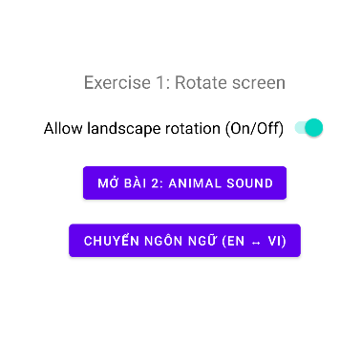
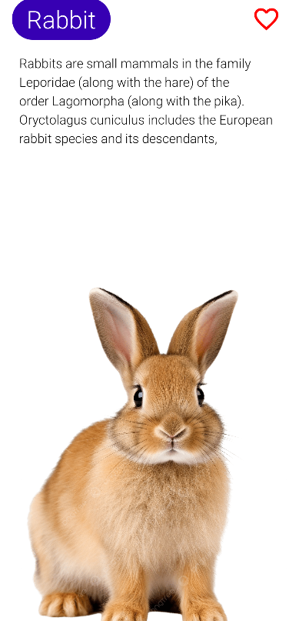
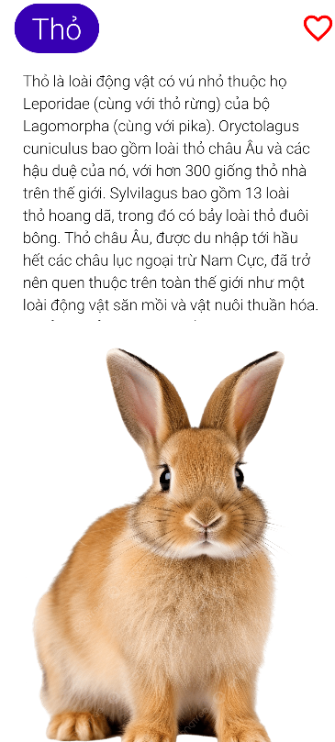
Code:
- AnimalActivity
package com.example.truyencuoi;
import android.os.Bundle;
import android.widget.ImageView;
import androidx.appcompat.app.AppCompatActivity;
public class AnimalActivity extends AppCompatActivity {
private boolean isFavorite = false;
@Override
protected void onCreate(Bundle savedInstanceState) {
super.onCreate(savedInstanceState);
setContentView(R.layout.activity_animal);
ImageView ivFavorite = findViewById(R.id.iv_favorite);
ivFavorite.setOnClickListener(v -> {
isFavorite = !isFavorite;
if (isFavorite) {
ivFavorite.setImageResource(R.drawable.ic_heart_filled);
} else {
ivFavorite.setImageResource(R.drawable.ic_heart_empty);
}
});
}
}
12 Bai1Activity

package com.example.truyencuoi;
import android.content.Intent;
import android.content.SharedPreferences;
import android.content.pm.ActivityInfo;
import android.content.res.Configuration;
import android.os.Bundle;
import android.widget.Button;
import android.widget.Switch;
import androidx.appcompat.app.AppCompatActivity;
import java.util.Locale;
public class Bai1Activity extends AppCompatActivity {
private static final String PREF_NAME = "settings";
private static final String KEY_ALLOW_ROTATE = "allowRotate";
private static final String KEY_LANGUAGE = "language";
@Override
protected void onCreate(Bundle savedInstanceState) {
// Áp dụng ngôn ngữ đã lưu trước
applySavedLocale();
super.onCreate(savedInstanceState);
// Áp dụng orientation lưu trước
applyOrientationSetting();
setContentView(R.layout.activity_bai1);
Switch sw = findViewById(R.id.switch_orientation);
Button btnOpenBai2 = findViewById(R.id.btn_open_bai2);
Button btnChangeLang = findViewById(R.id.btn_change_lang); // 🔹 nút đổi ngôn ngữ
SharedPreferences pref = getSharedPreferences(PREF_NAME, MODE_PRIVATE);
boolean allowRotate = pref.getBoolean(KEY_ALLOW_ROTATE, true);
sw.setChecked(allowRotate);
// ===== XỬ LÝ SWITCH XOAY MÀN HÌNH =====
sw.setOnCheckedChangeListener((buttonView, isChecked) -> {
pref.edit().putBoolean(KEY_ALLOW_ROTATE, isChecked).apply();
if (!isChecked)
setRequestedOrientation(ActivityInfo.SCREEN_ORIENTATION_PORTRAIT);
else
setRequestedOrientation(ActivityInfo.SCREEN_ORIENTATION_SENSOR);
});
// ===== MỞ BÀI 2 =====
btnOpenBai2.setOnClickListener(v -> {
Intent intent = new Intent(Bai1Activity.this, AnimalActivity.class);
startActivity(intent);
});
// ===== ĐỔI NGÔN NGỮ =====
btnChangeLang.setOnClickListener(v -> {
String currentLang = pref.getString(KEY_LANGUAGE, "en");
String newLang = currentLang.equals("en") ? "vi" : "en";
pref.edit().putString(KEY_LANGUAGE, newLang).apply();
// Cập nhật lại Locale ngay lập tức
setLocale(newLang);
recreate(); // làm mới lại Activity để text đổi theo
});
}
// ====== HÀM LƯU VÀ ÁP DỤNG NGÔN NGỮ ======
private void applySavedLocale() {
SharedPreferences pref = getSharedPreferences(PREF_NAME, MODE_PRIVATE);
String lang = pref.getString(KEY_LANGUAGE, "en");
setLocale(lang);
}
private void setLocale(String langCode) {
Locale locale = new Locale(langCode);
Locale.setDefault(locale);
Configuration config = new Configuration();
config.setLocale(locale);
getResources().updateConfiguration(config, getResources().getDisplayMetrics());
}
// ====== ÁP DỤNG XOAY MÀN HÌNH ======
private void applyOrientationSetting() {
SharedPreferences pref = getSharedPreferences(PREF_NAME, MODE_PRIVATE);
boolean allowRotate = pref.getBoolean(KEY_ALLOW_ROTATE, true);
if (!allowRotate)
setRequestedOrientation(ActivityInfo.SCREEN_ORIENTATION_PORTRAIT);
else
setRequestedOrientation(ActivityInfo.SCREEN_ORIENTATION_SENSOR);
}
}
- activity_animal
<?xml version="1.0" encoding="utf-8"?>
<LinearLayout xmlns:android="http://schemas.android.com/apk/res/android"
xmlns:tools="http://schemas.android.com/tools"
android:orientation="vertical"
android:padding="10dp"
android:layout_width="match_parent"
android:layout_height="match_parent">
<TableRow
android:layout_width="match_parent"
android:layout_height="wrap_content"
android:layout_marginHorizontal="10dp"
android:layout_marginTop="10dp">
<TextView
android:id="@+id/tv_animal_name"
android:layout_width="wrap_content"
android:layout_height="wrap_content"
android:background="@drawable/bg_radius"
android:paddingHorizontal="20dp"
android:paddingVertical="6dp"
android:text="@string/txt_name"
android:textSize="34sp"
android:textColor="@color/white"
android:fontFamily="sans-serif-light" />
<View
android:layout_width="0dp"
android:layout_height="match_parent"
android:layout_weight="1" />
<ImageView
android:id="@+id/iv_favorite"
android:layout_width="40dp"
android:layout_height="match_parent"
android:src="@drawable/ic_heart_empty"
android:tint="#FF0000"
tools:ignore="ContentDescription" />
</TableRow>
<ScrollView
android:layout_width="match_parent"
android:layout_height="300dp"
android:layout_margin="10dp">
<LinearLayout
android:layout_width="match_parent"
android:layout_height="wrap_content"
android:orientation="vertical">
<TextView
android:id="@+id/tv_animal_desc"
android:layout_width="match_parent"
android:layout_height="wrap_content"
android:padding="10dp"
android:text="@string/txt_desc"
android:textSize="18sp"
android:textColor="@color/black"
android:fontFamily="sans-serif-light"
android:lineSpacingExtra="5dp" />
</LinearLayout>
</ScrollView>
<ImageView
android:id="@+id/iv_animal"
android:layout_width="match_parent"
android:layout_height="0dp"
android:layout_weight="1"
android:scaleType="centerCrop"
android:src="@drawable/bg_rabbit"
tools:ignore="ContentDescription" />
</LinearLayout>

- activity_bai1
<?xml version="1.0" encoding="utf-8"?>
<LinearLayout xmlns:android="http://schemas.android.com/apk/res/android"
android:orientation="vertical"
android:gravity="center"
android:padding="24dp"
android:layout_width="match_parent"
android:layout_height="match_parent">
<TextView
android:id="@+id/tv_title"
android:text="@string/bai1_title"
android:textSize="20sp"
android:layout_marginBottom="24dp"
android:layout_width="wrap_content"
android:layout_height="wrap_content" />
<Switch
android:id="@+id/switch_orientation"
android:text="@string/switch_label"
android:textSize="18sp"
android:layout_width="wrap_content"
android:layout_height="wrap_content" />
<!-- NÚT MỞ BÀI 2 -->
<Button
android:id="@+id/btn_open_bai2"
android:layout_width="wrap_content"
android:layout_height="wrap_content"
android:text="Mở Bài 2: Animal Sound"
android:layout_marginTop="24dp" />
<!-- 🔹 NÚT CHUYỂN NGÔN NGỮ -->
<Button
android:id="@+id/btn_change_lang"
android:layout_width="wrap_content"
android:layout_height="wrap_content"
android:text="Chuyển Ngôn Ngữ (EN ↔ VI)"
android:layout_marginTop="16dp" />
</LinearLayout>
strings.xml
<?xml version="1.0" encoding="utf-8"?>
<resources>
<string name="app_name">TruyenCuoi</string>
<string name="bai1_title">Exercise 1: Rotate screen</string>
<string name="switch_label">Allow landscape rotation (On/Off)</string>
<string name="txt_name">Rabbit</string>
<string name="txt_desc">Rabbits are small mammals in the family Leporidae (along with the hare) of the order Lagomorpha (along with the pika). Oryctolagus cuniculus includes the European rabbit species and its descendants,</string>
</resources>
strings.xml
<?xml version="1.0" encoding="utf-8"?>
<resources>
<string name="app_name">Truyện Cười</string>
<string name="bai1_title">Bài tập 1: Xoay ngang màn hình</string>
<string name="switch_label">Cho phép xoay ngang (Bật/Tắt)</string>
<string name="txt_name">Thỏ</string>
<string name="txt_desc">Thỏ là loài động vật có vú nhỏ thuộc họ Leporidae (cùng với thỏ rừng) của bộ Lagomorpha (cùng với pika). Oryctolagus cuniculus bao gồm loài thỏ châu Âu và các hậu duệ của nó, với hơn 300 giống thỏ nhà trên thế giới. Sylvilagus bao gồm 13 loài thỏ hoang dã, trong đó có bảy loài thỏ đuôi bông. Thỏ châu Âu, được du nhập tới hầu hết các châu lục ngoại trừ Nam Cực, đã trở nên quen thuộc trên toàn thế giới như một loài động vật săn mồi và vật nuôi thuần hóa. Với ảnh hưởng rộng rãi đến sinh thái và văn hóa, thỏ (hay “bunny”) là một phần của cuộc sống hàng ngày — làm thực phẩm, quần áo, bạn đồng hành và là nguồn cảm hứng nghệ thuật.</string>
</resources>

